Test Row DFT Check

Part-1: How to Use the software
Part-2: How to interpret the report/data generated by DFT Checker

Part-1: How to Use the software (Atlantis 6.6.3.0)

- Click on Search Database
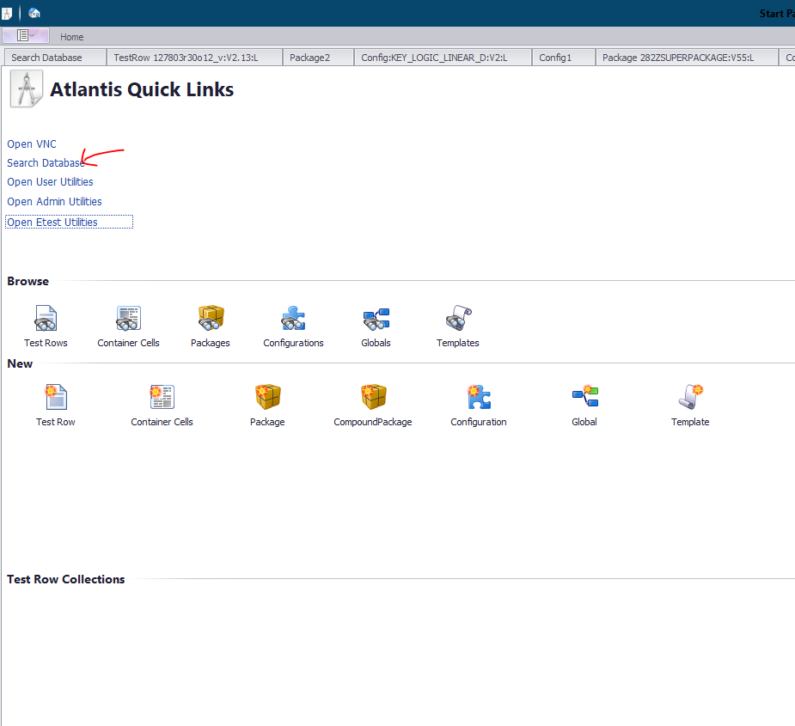

- Click on DFT rule checker
Make sure to use TestRows for most oprions to show up. Don’t use scribe line.
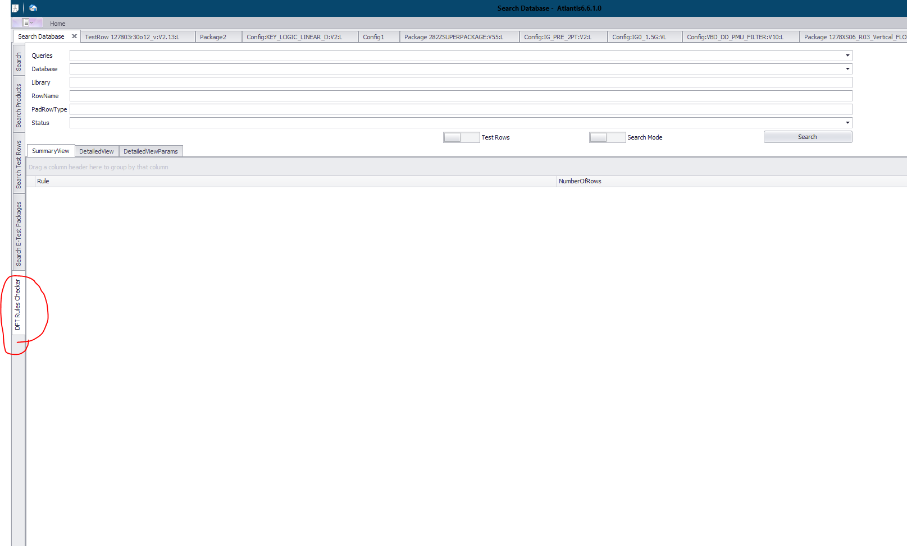

- For Queries Select these (please ignore the other rules for now):
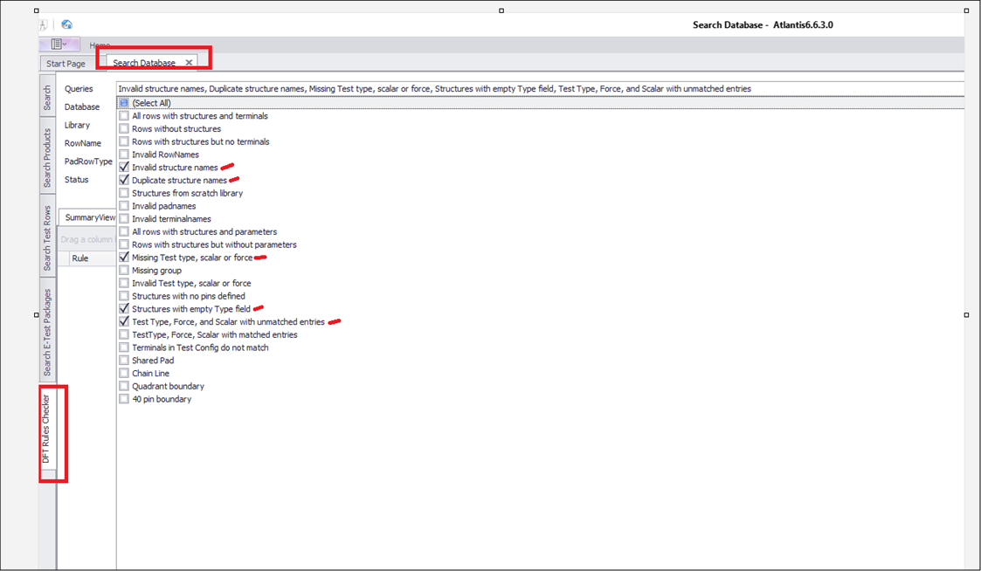
- Select these to check more than one row using file upload mode.
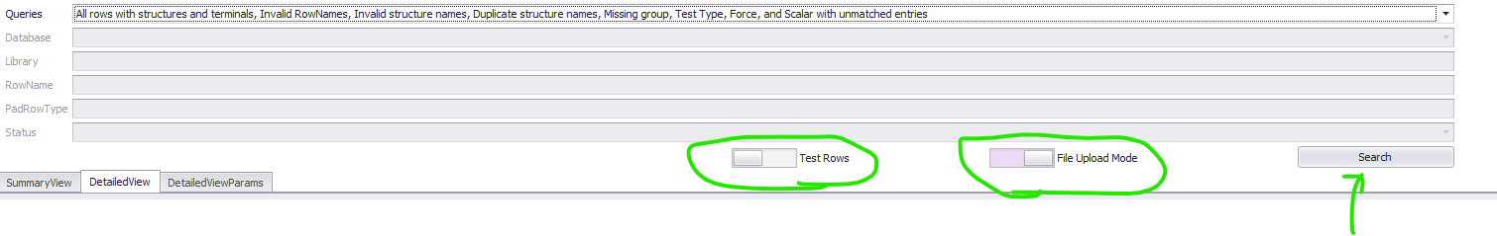

- Click on Search to select your file with row information:
.csv file format for file upload mode:
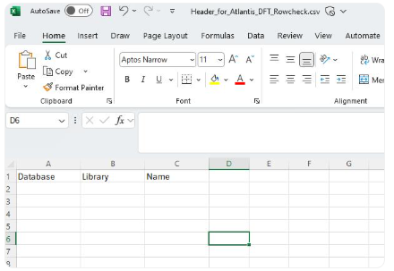

Example:
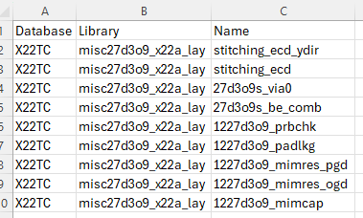
- Example of output when the check is done:
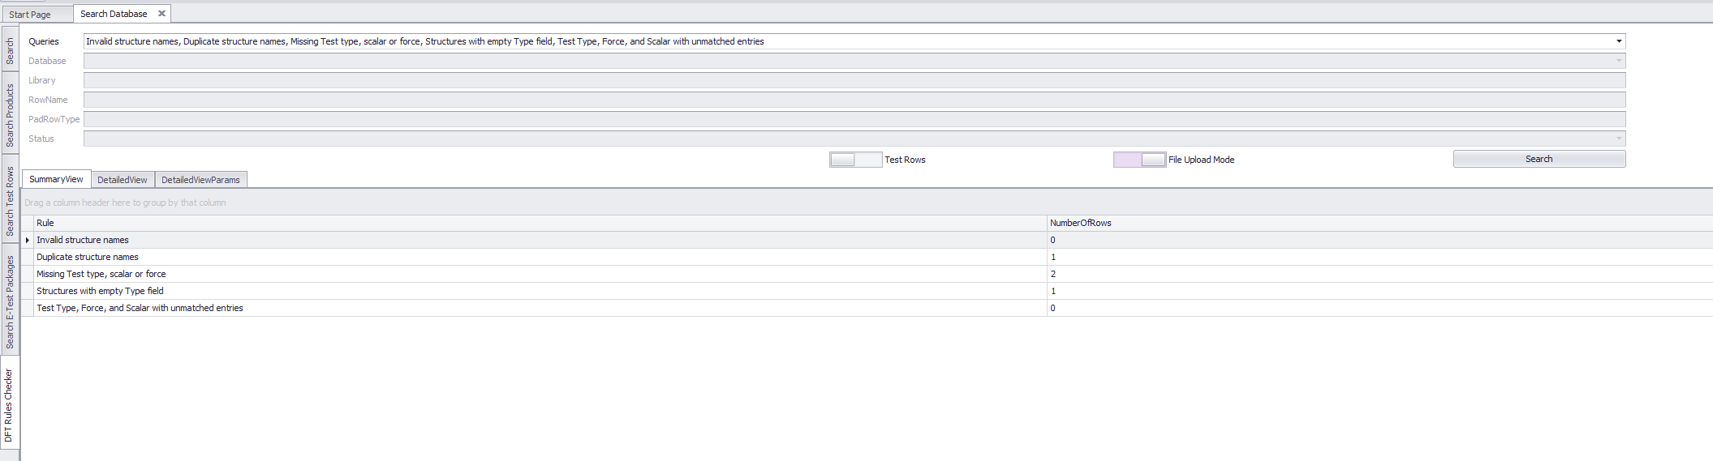

Part-2: How to interpret the report/data generated by DFT Checker

It can help us figure out the following potential errors.
- Invalid Structure Name
- Duplicate Structure Name
- Structure with empty Type field
- Unmatched Entries

- Invalid Structure Name
Go to DetailedView. Then Go to Rule: Invalid Structure names.

- Structure name character limit 55

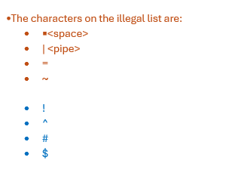

Here is an example issue with the structure name. These have ‘space’ in between characters which is not allowed.

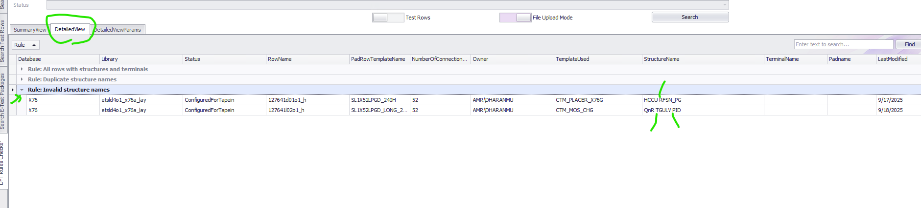

- Duplicate Structure Name
Go to DetailedView. Then Go to Rule: Duplicate structure names. This will open up a window like below.
Please ignore any structure with no test type defined (will not go into the super-package).
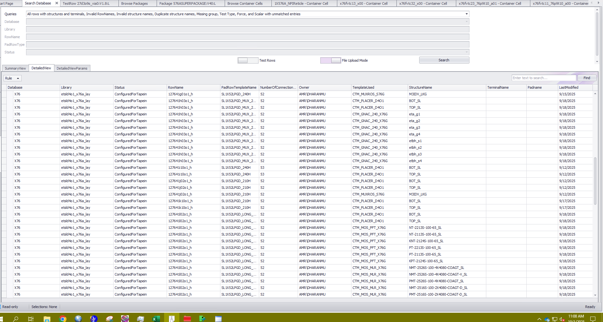

Example of False flag with missing ‘Test Type’:
For example, in the screen capture below the GNAC is missing ‘Test Type’ and will not be tested and will not end up in the super-package.
So, we need to ignore any message regarding GNAC.
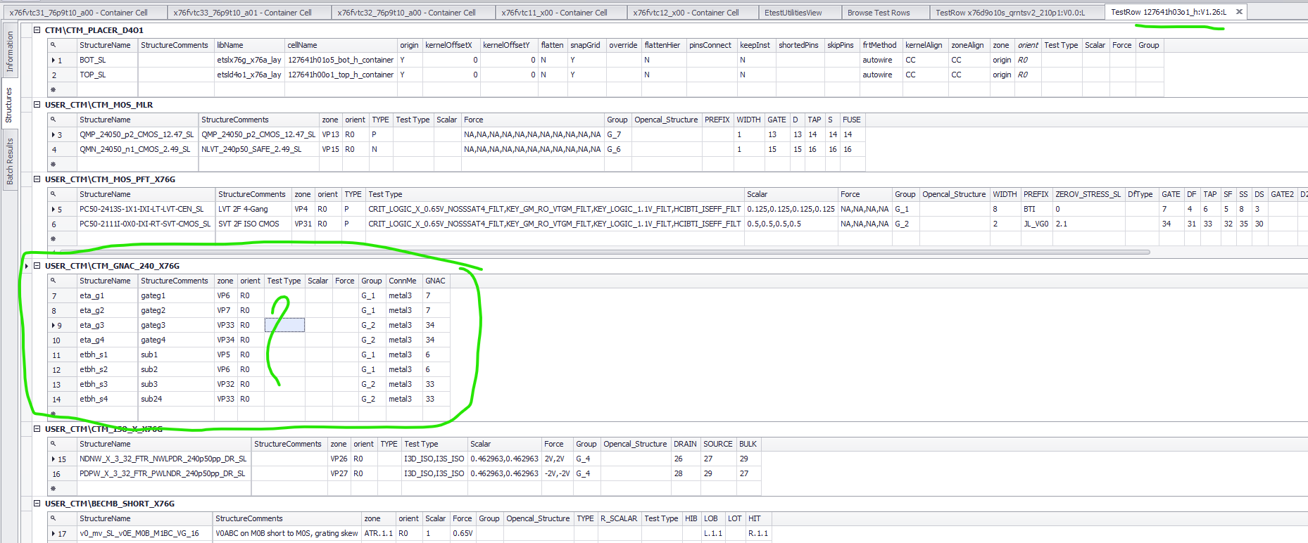
Example of Correct flag with present ‘Test Type’:
This structure has ‘Test Type’ defined and it will be tested. So, any message regarding this structure needs to be taken care of seriously.
Here duplicate structure name really exists !! Fix it !!
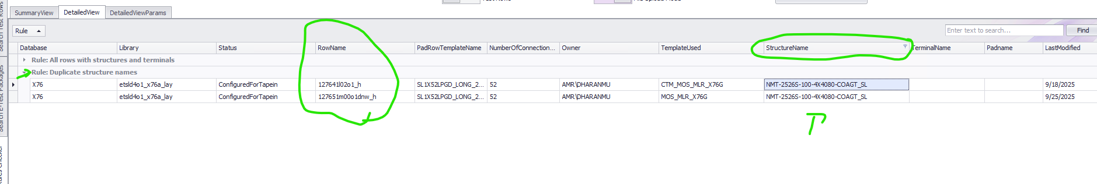
- Structure with empty Type field
This would flag structure if the ‘Type’ field in empty. The ‘Type’ field must be populated with either ‘P’ for P-type structure and ‘N’ for N-type structure. This is a must for ensuring the correct bias polarity for the measurement.

Note: For opencal structures this could be ignored.

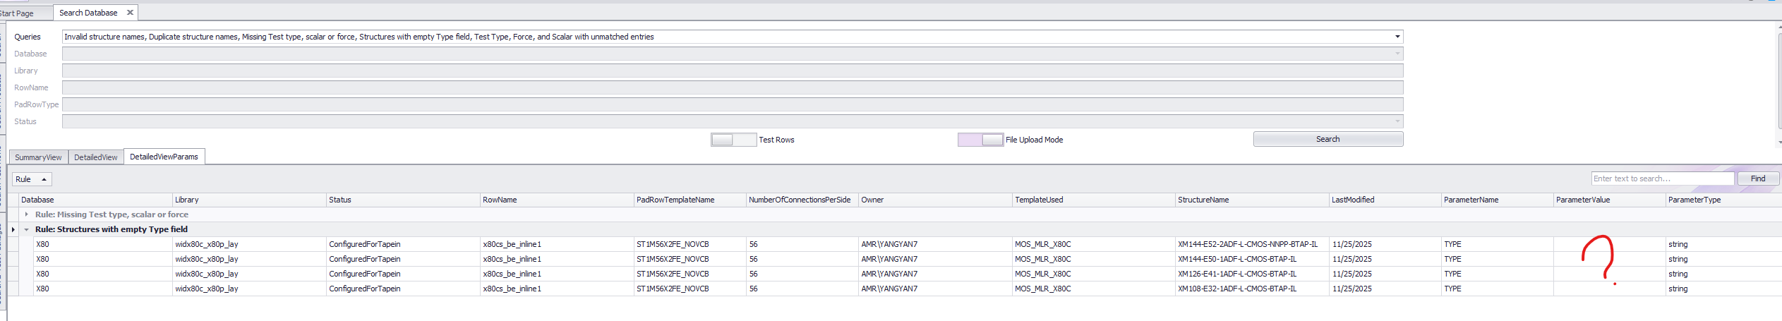
- Unmatched Entries
Go to ‘DetailedViewParams’. Then go to “Rule: Test type, Force and scaler for Unmatched Entries.
The number of comma-separated elements must be same for Test type, Force and Scalar columns. If not, the structure will be missing from the super-package for test-selection.
Here is an example. The TestType column has two elements where the Force and the Scalar columns have three. These structures with rule violation will be missing from the super-package.

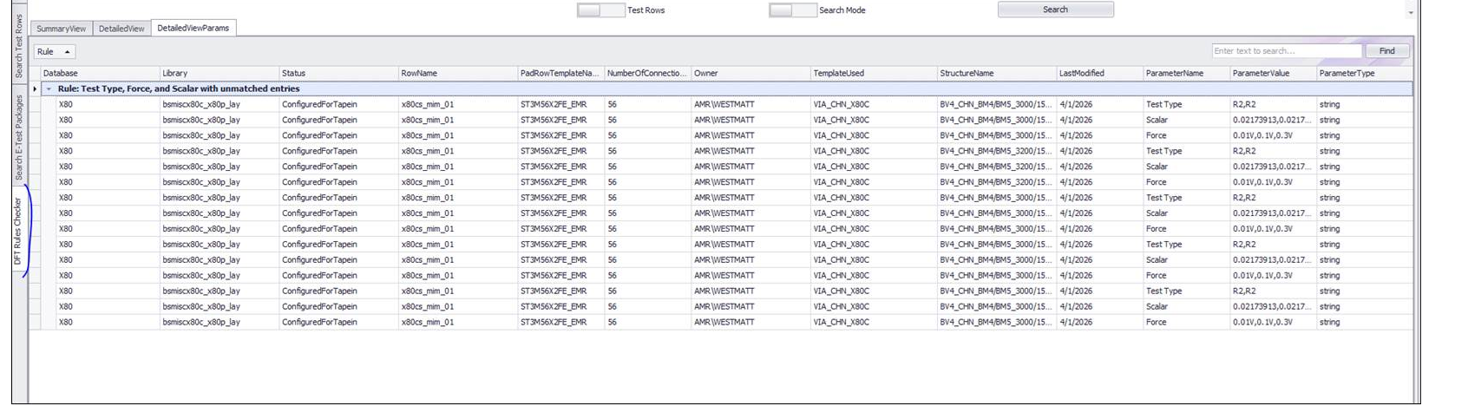

Exporting DFT checker result

There is a feature available to export DFT checker results as CSV or Excel file. You need to right-click on the table to export.

